# DESN705 Assessment One: Research Report

## Section 1: Framing the System

In your groups complete the *Rich Context* Tool. Identify and discuss what you consider to be the main challenge for your local community in the following four areas. You are expected to research this issue and provide references to support your argument.

1. Institutional Structures

The main challenge we believe South Auckland is facing is Health Care. With such a large community, and especially one with higher levels of deprivation than other parts of Auckland (EHINZ, 2018), having access to high-quality Health Care is vital. Through research and discussion in our group, we found that East Care, the local accident, and medical walk-in clinic is no longer open 24/7, citing issues with being able to run the service safely due to a lack of funding being the main reason to stopping this service (East Care 24 hour Accident & Medical Clinic, 2021). With this clinic reducing opening hours, more of the community will be visiting Middlemore Hospital or travelling further out of the community to access 24/7 Health Care. At this current point, the only 24/7 health care service that is not at Middlemore Hospital is Whitecross at Greenlane Ascot (Healthpoint, 2021). The website is also incorrectly displaying East Care as being open 24/7.

We also briefly discussed the re-structuring of East Tamaki Health Care to what it is now, Tamaki Health. The management service organisation is now the largest independent primary healthcare group, supporting local doctors’ countrywide (Tamaki Health, 2021). However, there is the concern this may diminish from the targeting health care support the local East Tamaki region was receiving from the Health Care Organisation. Overall, Health Care in South Auckland, especially Health Care targeted at the specific needs of the community is seriously lacking, and it may be too early to see the full effects of these changes.

2. Economic Structures

When discussing the economic structures that may pose a challenge to our local communities of South Auckland, housing was a large part of that discussion, especially the disparity in housing situations between suburbs. The Auckland regional average for households who do not own the property they are living in is 40.6%, while in the Howick Local Area this is much lower at 33.3%, and Otara-Papatoetoe is much higher at 56.9%. For those households that are renting, the average rent in Howick is $530 weekly, and in Otara-Papatoetoe it is $390, compared to $450 (Statistics New Zealand, 2018a,b,d). Recent figures released by the Ministry of Social Development also highlighted that the Auckland region as a whole had the highest number of children living in motels, as compared to stable living situations (RNZ, 2021).

We also discussed the development in the Highbrook Business Park, a recently developed industrial area just past Otara. This is located on what was previously the estate of Sir Wolf Fisher of Fisher and Paykel (Goodman, 2019). In the last 15 years, the business park has been developed to what it is today; a hub of local and overseas business such a Courier Post and Ford, as well as cafes and eateries.

3. Culture

While completing the Rich Context tool, we discovered that there was less of a challenge when it came to culture in South Auckland. Auckland as a whole has an 11.5% Maori population, 15.5% Pacific population and 28.2% Asian population (Statistics New Zealand, 2018a). When compared to this, the Howick local area has a 46.5% Asian population (Statistics New Zealand, 2018b), the Otara-Papatoetoe local area has a 46% Pacific population (Statistics New Zealand, 2018c), and the Papakura local area has a 26.8% Maori population (Statistics New Zealand, 2018d). While spread out, there are large areas of South Auckland that have a higher than average non-Pākehā population. This diversity has developed a culture of inclusion, where major religious and cultural events and sacred places are revered by all. Examples of this are the Fo Guang Shan Buddhist Temple in Flat Bush, which regularly opens its doors to the public (Fo Guang Shan, n.d.) as well as the Diwali festival held at the Vodafone Events Centre in Manukau yearly (Auckland For Kids, 2021)

We did however find that not all culture in South Auckland is seen as positive to those outside of the area. In 2018 youth from various local schools got together to challenge the perception of South Auckland being full of ‘criminals’ and ‘thugs’ but instead being full of hard-working families and students (RNZ, 2018). In 2017 Stuff ran an article about locals in Otara pushing back on the perception that the suburb was ‘unsafe’, as many from outside the area felt. This came from a survey done by Auckland Council in 2012, which found that South Auckland was perceived to be the most unsafe area of Auckland, mostly by people who lived further away from the area (Williamson & Ford, 2017)

4. Practices

As with cultures, while completing the Rich Context tool, the challenges we found for practices were less challenges in sense of things we wanted to change but were things we wanted to preserve. These practices are closely related to culture, as the practices many people in South Auckland take part in are related to their culture. We found that there is a practice of attending church and other religious gatherings, and this is a large part of practices in South Auckland. In 2018 42.6% of the population reported having no religion (Statistics New Zealand, 2018a), whereas Otara-Papatoetoe reported only 18.2% no religion (Statistics New Zealand, 2018d). in 2015 it was reported that South Auckland was the most religious place in New Zealand (New Zealand Herald, 2015). Even if an individual is not religious in South Auckland, it is hard not to notice the increase in religion in the area. While it may be anecdotal, each of us in our group, as well as many of our friends, remember going to local church youth groups growing up.

Finally, the idea of people working locally also came up while completing this tool. While distance to work is not something that is captured in the local census, we all mirrored this experience of having the majority of our households working in very similar areas to those they lived in. This will add an interesting challenge of its own as we continue to look at how we can support these local communities in a post-COVID-19 world.

## Section 2: Listening to the System

1. Actant map: Complete the *Actant Map* Tool and insert a picture.

* Different experience – one is a university student, the other is a local high school teacher.
* Different perspective – a home-owner vs. someone living with their parents.
* They are very similar in the beginning – both enjoy living in the area and have been living here for a long time
* One can only see the crime, while the other can see the struggle that is creating the crime.
* Youth are struggling – local teacher seeing young people dropping out
* More unemployment means more crime
* More crime in local area
* Have lived here for years, but getting less safe
* More youth being hooligans

2. Reflect

Reflect on your experience of interviewing the 2 people for your project. What new and interesting insights did you learn from them?

The two interviews that I completed were very different, and while I expected different responses from my two interviewees, I didn’t quite expect them to be as different as they are. One of the individuals I interviewed was a colleague of mine, who is also studying here at AUT. We currently have very similar experiences within our local community, and I got very similar responses to the questions to how I would have answered. The second individual I interviewed was my mum, who is a teacher at a local decile two high school. The school at which she teaches is in a lower socioeconomic area, despite being quite close to the flashier side of South Auckland. Even though we are related, we do live quite different lives and I got very different answers to my interview.

The main insight is that Brandon, my colleague, had a rather self-centred view of issues withing the local community. The pressure points he identified were in relation to having safe local parks be available 24/7, such as having lights at soccer fields available to the public. He highlighted a personal need to play football with his friends whenever he wanted. While there may be other individuals who would also be impacted by having parks available and lit safely all the time, it was a personal view of the potential needs the local community may have.

In comparison, the issues my mum bought up were less personal, and highlighted the experience she has as a teacher. She bought up issues relating to employment, having seen many of her students drop out of high school under pressure to join the workforce and support their families. She really felt for these students, as she felt that many of them would have gone on to be high achievers in their chosen fields after completing high school, but felt that their opportunities were being cut short as a result of dropping out.

Both of my interviewees also talked about security and safety – one of the issues that was bought up in interviews my group members did. Brandon talked about car thieves, and window washers at intersection, while my mum bought up house break-ins. Both were relating their own experiences and fears to the issue of safety, but it was ultimately different sides of the same issue. I found it really interesting to see how the two individuals I interviewed approached and viewed the same issues.

I found the interviews challenging seeing how my own answers to the interview questions were very similar to those answers from Brandon, but very different from my mum. This was especially challenging as I interviewed Brandon first, and had a similar self-centred approach to the questions, and then was affronted by the apparent selflessness found in the answers from my mum. Overall, the interview process was interesting, and there are some aspects of the interview that I wish I were able to expand on. I have learnt more about the community from the interviews, and can now see why interviews are a useful avenue for gathering information from your local community.

## Section 3: Understanding the System

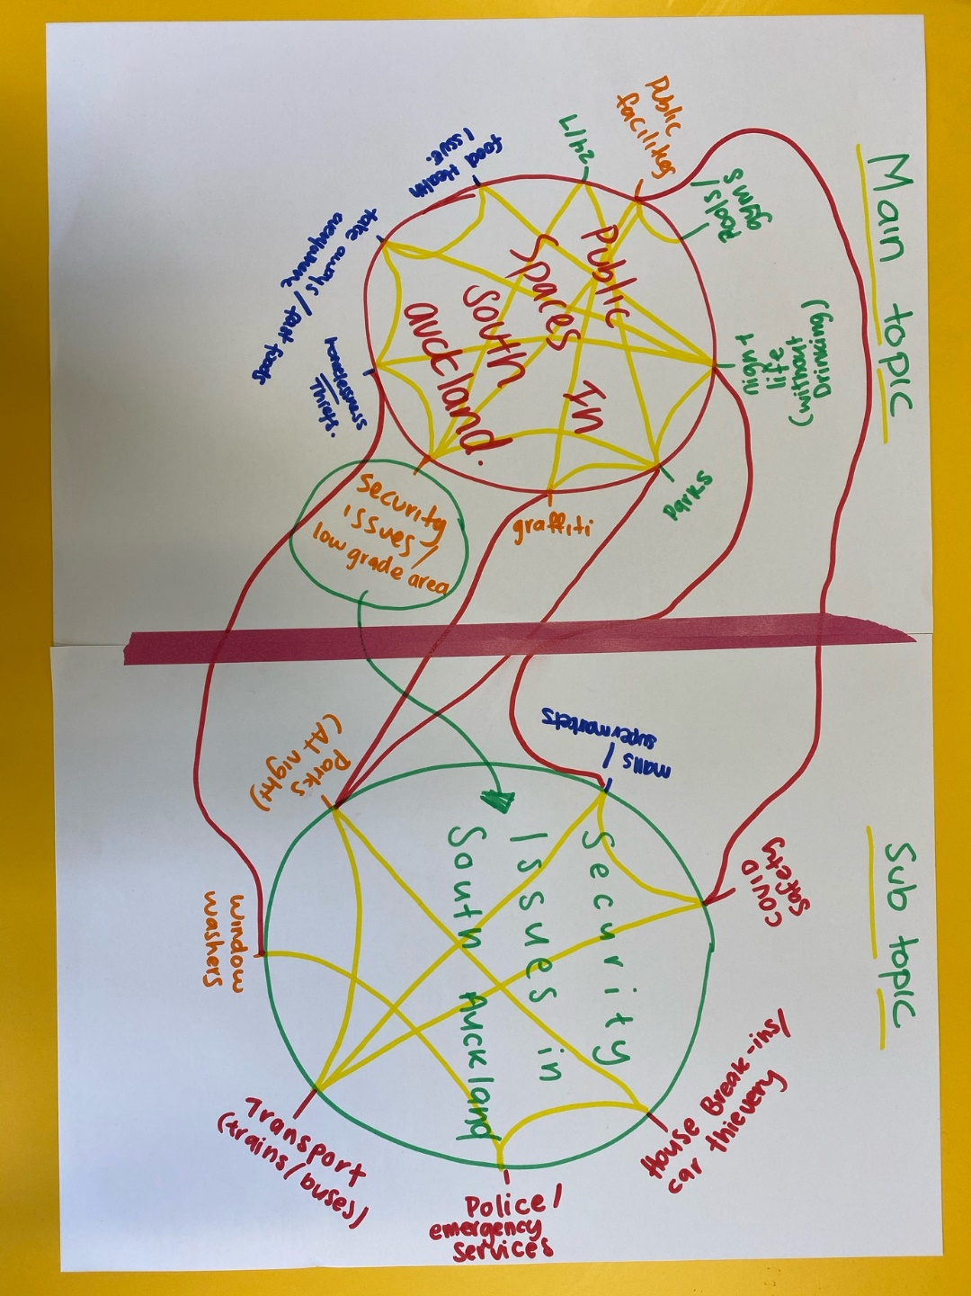

1. System Maps

Complete the *Systems Maps* and insert pictures.

2. Reflect

Reflect on your experience of using the systems mapping tools.

I found the interconnecting circles tool rather interesting to complete with my team. We started with mapping the different aspects of the public spaces issue in South Auckland, and then noticed that a lot of these aspects also related to the security issues in South Auckland. I found this tool challenging, as it forced me to separate my feelings, and preconceptions about these issues from the facts and players in the issues. I also found it insightful being able to see how the aspects of these issues related to each other, as well as how the two major issues of public spaces and security issues were different but interconnected.

I also really enjoyed the visual aspect of this tool, being able to play with colour to show how the different aspects of the issues are connected. This freeform visualisation task enabled me to discover these connections in an organic and creative way, which I feel developed a deeper understanding of these interconnected issues. Overall, I really enjoyed going through this process to dive deep into the issues we had identified in our local community, and explore exactly how they are connected.

3. Insights

What are three new insights about your project that you gained from these exercises?

As briefly discussed in the reflection above, a major insight that was gained by completing this exercise was how our two major issues were actually connected. By starting with what we felt was the major issue we were going to focus on, which was the public spaces available in South Auckland, we were also able to understand how the overall security issue related. As a group, we discovered that these were not two separate issues, but are instead one issue with a related sub-issue. While the aspects of our security issues are not only related to public spaces, but many of these aspects are, and improving the security in the few public spaces we have will improve the use of those public spaces.

We also found that the whole issue of security was a lot broader than we had originally thought. While we understood that security and safety went hand in hand, and may people we interviewed mentioned the rising crime levels, we had not personally explored the aspect of trust in our emergency services, such as police and ambulance. None of our interviewees mentioned this, and unfortunately we only explored this aspect after completing the interviews, but it is a very interesting aspect to security and safety that we are looking forward to exploring further.

Finally, we were able to broaden our understanding of what the public spaces we were referring to in our earlier conversations. We realised that without further descriptors, ‘public spaces’ is too broad for members of our local community to understand. We looked into the aspects of exercise facilities such as gyms and pools, as well as non-council spaces such as malls. While we have not decided yet as a group what our scope for ‘public spaces’ will be in our final design, it was interesting to develop these ideas and issues further.

## Section 4: Defining the Desired Future

1. Value Proposition

Complete the *Value Proposition* and insert a picture of your completed tool. The purpose of this tool is to make the ideal future explicit, by listing the benefits that the interventions will bring to the future individuals, organisations and society.

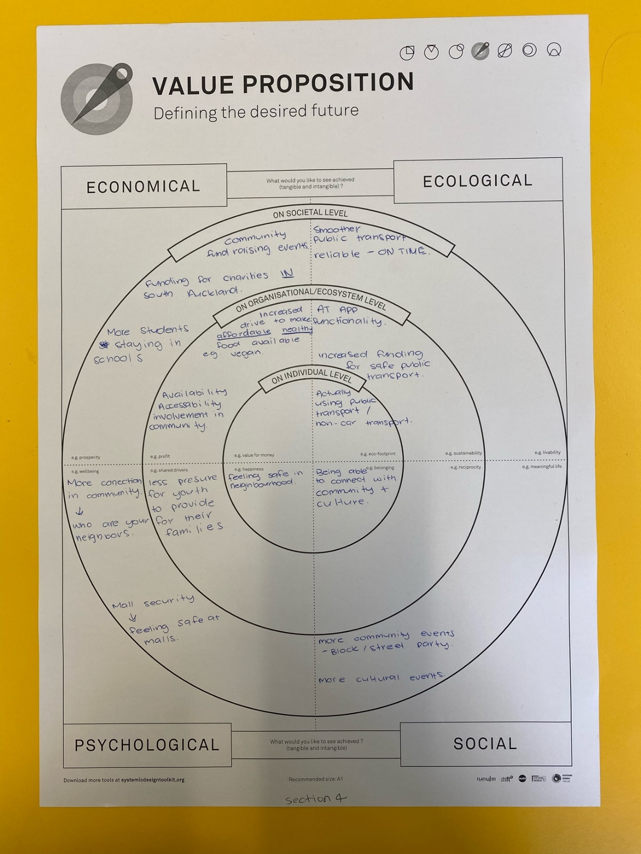

2. Insights

Identify and discuss what you consider to be one of the key economic, ecological, psychological, and social benefits that could result from your interventions.

*Economic:*

From an economic standpoint one of the major benefits from our interventions in South Auckland is fewer students; high school and university; feeling the pressure to drop out and enter the workforce to support their families. In the long run, we would also love to see an increase in charities and charitable programmes in South Auckland that are run by locals to South Auckland for those living in South Auckland. This would also increase local support for small businesses, meaning those small local businesses can become more resilient to changes in the economic climate. Our interventions would also mean an increase in involvement from these local businesses to support community events and community fundraising. Developing a way for businesses and the wider community as a whole to support one another will create a more economically stable South Auckland.

*Ecological:*

Understanding the ecological benefits to South Auckland was slightly harder to complete. We hope that as these community interventions take place that more of the community would be catching public transport. In Section three we identified that security issues were a large subcomponent of our main public spaces issue and that ideally as we worked to solve this security issue, that more people would feel safer on and around public transport and this would increase patronage on various forms of public transport.

We also hope that developing community interventions to solve the lack of safe public spaces will also increase the local spaces with native flora and fauna. By developing parks with native plants, we can work as a community to increase the native birds and other animals present in our local communities, which would have a positive impact on both the environment, as well as the mental wellbeing of our community.

*Social:*

Looking at the potential social benefits we could bring about with our interventions, we found that most of these benefits were the same on a societal and individual level. The individuals in our local community will benefit by being able to connect with their community and culture. We intend to better connect individuals with groups and support networks that enable them to thrive. This connection will also be felt at a societal level, with everyone being able to take part and experience different cultural expressions. As individuals become more connected with *their*local community, our local community as a whole will become more connected. These benefits will also spread to the economic side of our community, with local small and medium business owners – especially those in cultural businesses such as local food providers, will be able to connect with members of those cultural communities. This may mean that more events are held, and the community will continue to connect even further.

*Psychological:*

The psychological benefits we found are a culmination of all the previous benefits. As our community gets more connected, we have a more resilient community. As neighbourhoods start to reach out and get to know one another, we develop safer and more welcoming neighbourhoods. As local businesses branch out and support, and are supported back by the local communities, we have more of these local businesses staying open, and fewer of our high school and university students dropping out. All of this will reduce the psychological strain we currently feel in our community, especially after COVID-19. At the start of the pandemic, many felt the community of South Auckland drop the connection to support one another, and instead many of the community acted in self-defence. This resulting all-for-one panic has left noticeable scars on how we support each other, and many in the community are still feeling the fight or flight of the pandemic.

# References

Auckland For Kids. (2021). Taranas Manukau Diwali 2020. Retrieved from https://www.aucklandforkids.co.nz/events/taranas-manukau-diwali-2020/

East Care 24 hour Accident & Medical Clinic. (2021). East Care Group Closes Overnight Service. Retrieved from https://www.eastcare.co.nz/newhours/

EHINZ. (2018). Socioeconimic Deprivation Profile. Retrieved from https://www.ehinz.ac.nz/indicators/population-vulnerability/socioeconomic-deprivation-profile/

Fo Guang Shan. (n.d.). Auckland Tea House. Retrieved 18 April 2021 from https://fgs.org.nz/english/tea-house/

Goodman. (2019, March). Highbrook Business Park Auckland New Zealand. Retrieved from https://nz.goodman.com/-/media/Files/Sites/New-Zealand/property/properties-for-lease/Highbrook/Development-brochure/Highbrook-Case-Study-brochure.pdf

Healthpoint. (2021). Counties Manukau Health Emergency Department. Retrieved from https://www.healthpoint.co.nz/public/emergency/counties-manukau-health-emergency-department/#other

New Zealand Herald. (2015, May 13). Interactive: The map that shows Wellington is 'godless' capital of New Zealand. Retrieved from https://www.nzherald.co.nz/nz/interactive-the-map-that-shows-wellington-is-godless-capital-of-new-zealand/U2P2ASO5GFBZ2BDUZ2AD4AMY3A/

RNZ. (2018, July 6). Youth unite to change negative perceptions of South Auckland. Retrieved from https://www.rnz.co.nz/international/pacific-news/361246/youth-unite-to-change-negative-perceptions-of-south-auckland

RNZ. (2021, April 13.) 'Motel generation' feared as emergency housing need continues. Retrieved from https://www.rnz.co.nz/national/programmes/checkpoint/audio/2018791400/motel-generation-feared-as-emergency-housing-need-continues

Statistics New Zealand. (2018a). Auckland Reigion. Retrieved from https://www.stats.govt.nz/tools/2018-census-place-summaries/auckland-region#ethnicity

Statistics New Zealand. (2018b). Howick Local Board Area. Retrieved from https://www.stats.govt.nz/tools/2018-census-place-summaries/howick-local-board-area#ethnicity-culture-and-identity

Statistics New Zealand. (2018c). Otara-Papatoetoe Local Board Areaa. Retrieved from https://www.stats.govt.nz/tools/2018-census-place-summaries/otara-papatoetoe-local-board-area

Statistics New Zealand. (2018d). Papakura Local Board Area. Retrieved from https://www.stats.govt.nz/tools/2018-census-place-summaries/papakura-local-board-area#ethnicity-culture-and-identity

Tamaki Health. (2021). Retrieved from Tamaki Health Website: https://www.tamakihealth.co.nz/

Williamson, J. &. (2017, November 7). Ōtara: The reality is different to what the stereotypes picture it as. Retrieved from https://www.stuff.co.nz/auckland/local-news/manukau-courier/93137932/tara-the-reality-is-different-to-what-the-stereotypes-picture-it-as